
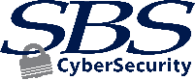

Educate your employees, board, and customers
Toolkit
Security
Awareness

About the Toolkit
Security Awareness Made Easy
We strongly believe in the power of education and security awareness training when it comes to creating a strong information security program. Your business and your customers deserve protection from cybersecurity threats. For that reason, we created this toolkit to help you easily build and share a strong cybersecurity culture to combat these concerns.
Training and education of not only your employees, but also your customers, is a key component to building a cybersecurity culture. It helps establish trust that your organization takes cybersecurity seriously and that you’re committed to doing what’s best for your employees and your customers.
Our talented employees, speakers, and instructors have taken part in hundreds of educational events from coast to coast. We have assembled a variety of ideas in this guide for easy access to grab and go security awareness resources!

Jon Waldman, CISA, CRISC
SBS Cybersecurity
President and Partner

SBS Resources


Hacker Hour
sbscyber.com/education/hacker-hour
This free webinar series offers an interactive training experience where our host is joined by an expert to discuss cybersecurity issues and trends.
Blog
sbscyber.com/blog
SBS experts are passionate about sharing their knowledge and insight with new blog posts each month.

eBooks
sbscyber.com/education/resource-library
Support your organization's cybersecurity culture with free eBook downloads containing tips, tricks, and best practices for cybersecurity.

Webinars
sbscyber.com
Our speakers regularly host webinars
to increase awareness and knowledge around top cybersecurity topics.
Stay Connected
sbscyber.com
Be the first to know when new content
is shared by joining the SBS mailing
list or following us on:
LinkedIn | Twitter | Facebook



Certifications
sbscyber.com/education/certifications
SBS Institute certifications prepare learners and financial institutions for cybersecurity threats and regulations. Each course is available online and is tailored to specific roles within an institution.



Visit sbscyber.com for more information on any of these resources.

Encourage Engagement
Build a Culture of Cybersecurity

It's crucial to provide basic cybersecurity knowledge, best practices, and tips on a regular basis. Establishing a strong culture of cybersecurity within your organization has advantages beyond just reducing cyber risks; it also instills confidence in your employees and customers, showing them that you prioritize their security.




- Share quizzes, crossword puzzles, or games to get customers and employees thinking about cybersecurity topics. Provide a prize or drawing for participants.
- Implement an employee reward or recognition program to show appreciation for following through with training, applying concepts, or passing a social
engineering test.

Share Your Knowledge
Make
It Fun
Host an
Event

- For business customers: Plan a lunch and learn
event that focuses on
the latest cybersecurity trends and tips for
securing their business.
- For the community:
Host a cybersecurity awareness day for community members to shred sensitive documents, listen to short presentations, and play cyber-themed games or trivia.
- For employees:
Have an external presenter conduct training to help increase engagement. Many speakers will also make it
fun by incorporating games or a prize for participants.
- For your board:
Have an expert discuss the trends they are witnessing and the risks associated to generate increased buy-in.
- Place or link to relevant cybersecurity tips, news stories, and alerts on
your website.
- Incorporate cybersecurity
tips into your on-hold message when customers call your business.
- Include a monthly tip in your newsletter or on your social media accounts to keep cybersecurity top-of-mind
for your customers.
- Encourage your customers and employees to
follow your organization
or other cybersecurity organizations on social media for cyber tips
and news.
- Place posters, articles, or other educational materials
in the entryway, break
room, bathroom, or other
meeting areas.


sbscyber.com/education/hacker-hour
Invite your business customers and employees to attend the Hacker Hour webinar series
hosted by SBS. This monthly series is an interactive and engaging cybersecurity training experience - free of charge.

Social Media Posts
Monthly Topic Ideas

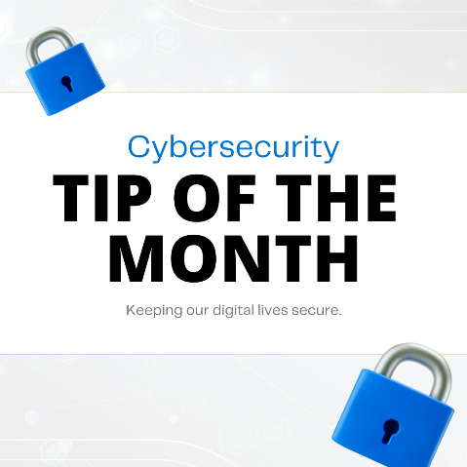
One quick and easy way to demonstrate your commitment to cybersecurity is to share your knowledge! Post cyber-related content to your social media accounts on a regular basis. Use the posts and hashtag below as a guide to get started.
Make your monthly cybersecurity posts stand out with a consistent graphic shared with each post. To use the cybersecurity tip of the month graphic, right click on the image and choose “Save as Picture.” Add your logo to the graphic for a quick branded option.
Topic:
Passwords

- Would you ever use one key to unlock your front door, start your car, and open the safe deposit box at the bank? No! Reusing a password for different accounts is doing just that. Do not use the same password for multiple systems, websites, or accounts. #BeCyberSmart
- Did you know hackers often use automated password-cracking tools that can try thousands of dictionary words to guess a password in a matter of seconds? Individual words, even with slight variations, are easy to guess, but a series of words in a passphrase makes them more secure. Try using a something like IL0v3B@seb@11 instead of baseballfan1. #BeCyberSmart
- According to recent studies, the average user has approximately 100 passwords to remember. If you need help managing all those passwords, do not store your list of passwords in a plain text file on your computer or on a sticky note under your keyboard. Instead, there are several trusted password management programs that can help you stay secure. #BeCyberSmart
Topic:
Phishing
- Phishing is by far the most common attack method performed by cyber criminals. That’s why it is important to treat every single email like it is a phishing attempt. Ask yourself three questions before clicking on any link or attachment. “Do I know the sender?” “Was I expecting this information?” “Why do they want me to click or send information?” If something seems suspicious, do not click. #BeCyberSmart
- What should you do if you receive a suspicious email? Do not take action or respond to the email until you verify it is not a cyber criminal sending you a phishing email. Call the person directly to verify the sender. #BeCyberSmart
- Beware of phishy emails. Always look for emails that come from a suspicious sender, offer a prize or enticing deal, contain typos and bad grammar, or request immediate action. When in doubt, throw it out! If an email, link, or post looks suspicious, delete it. #BeCyberSmart
Topic:
Remote
Work
- If you work remotely, make sure your home WiFi network is secured by a strong password. If possible, consider setting up a separate WiFi network for work and one for personal devices. #BeCyberSmart
- Business owners with remote employees should set up a virtual private network (VPN), which allows employees to work from home using a company-owned private network. #BeCyberSmart
- Keep it clean and secure! A machine that is up to date on security software, web browser systems, and operating systems is a machine that thrives. Don’t forget to keep it secure by enabling security features like codes, touch or face ID, and multi-factor authentication. #BeCyberSmart
- Did you know that when you use strong passwords, practice caution, and keep your anti-virus protection up to date that you’re following safe cybersecurity protocols? It’s true! Doing these things in addition to safe web surfing, locking your computer, and educating yourself will keep you safe in the cyber world. #BeCyberSmart
- See something, say something. If you see something suspicious, report it to your IT department or the proper authorities as soon as possible. Make sure everyone at your organization knows the proper reporting process. #BeCyberSmart
- Think before you app. Be thoughtful about which apps you download and allow to collect your personal information. #BeCyberSmart
- Find a USB drive? Give it to the IT department to verify its authenticity. Do not put it in to your computer to identify the owner. #BeCyberSmart
- Be WiFi savvy. Public wireless networks and hotspots are not secure. Avoid logging in to important accounts such as email and financial services while on a public network. #BeCyberSmart
- Practice layered security with multi-factor authentication (MFA) whenever possible. MFA can prevent a majority of account compromises. Yes, this extra layer of security adds a bit of inconvenience and another speed bump in the login process, but it is well worth the additional step. #BeCyberSmart
- S=Secure. Look for the “s” in https as part of the URL of a website you visit. It shows the authenticity of the security certificate on that webpage. #BeCyberSmart
- New threats and vulnerabilities are constantly being discovered. Not staying current on software updates and patches will leave your systems vulnerable to known attacks that could be avoided. It is the equivalent of leaving your doors unlocked in an unsafe neighborhood, and the internet is, most certainly, not a safe neighborhood. Keep a clean machine with current security software, web browser, and operating system. #BeCyberSmart
- A firewall helps prevent unauthorized access to or from a network. It is the first line of defense when it comes to guarding digital information not intended for the public eye. #BeCyberSmart
- Turn off Bluetooth if you are not using it. Wireless connections can be a gateway for hackers to access and steal the private data on your phone. #BeCyberSmart
- Have you heard of the 3-2-1 backup rule for important business data? It is a highly recommended guide for proper data backup. Always have THREE copies of your important data, utilize TWO different types of media when performing backups, and always keep ONE copy of your data offsite and ensure it is air-gapped. #BeCyberSmart
- Avoid the panic of losing an important file with a backup copy. Data can be lost due to a security breach or human error. Frequently back up your important files on the cloud or a local storage device. #BeCyberSmart
- As a base layer of protection, install and update anti-virus software on all devices connected to the Internet. Only use software from a trusted vendor and make sure you only have one anti-virus tool running on your device. #BeCyberSmart
- Here’s your reminder to uninstall mobile apps you no longer use! #BeCyberSmart
Topic:
Best
Practices

Educate
Security Reminders for Employees and Customers

Posters
Place posters in entryways, break rooms, bathrooms, or other meeting areas of your organization. You can also share with your customers for even more reach.
Visit sbscyber.com/education/resource-library to access these posters and more. Add your logo to the poster for a quick branded option.
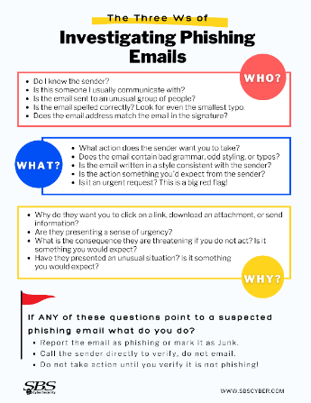
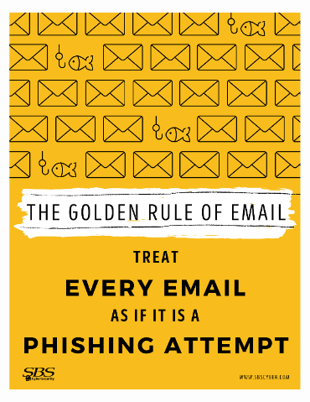
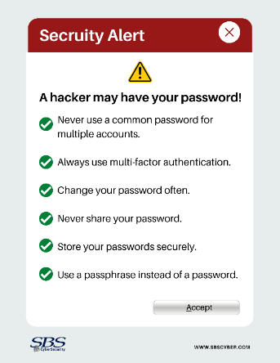
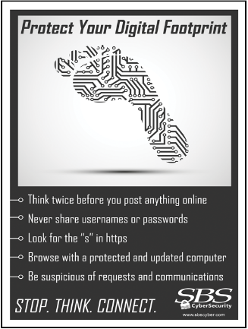

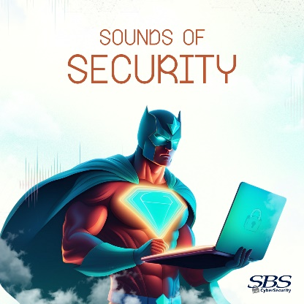
Cybersecurity Awareness Playlist
Turn up the volume on security! Share this playlist of catchy and thought-provoking tracks with your employees and customers. The playlist features songs from our exclusive AI-generated cybersecurity album: Sounds of Security. Each song in this album doubles as a learning tool, helping share key cybersecurity concepts through music. Whether it's remembering not to click suspicious links or reinforcing the importance of firewalls, these tracks make cybersecurity more approachable and relatable.
Get the playlist here: sbscyber.com/blog/sounds-of-security-cybersecurity-awareness-gets-a-soundtrack
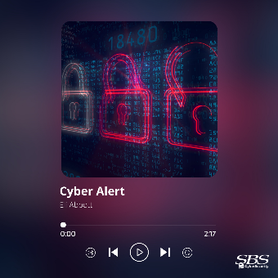
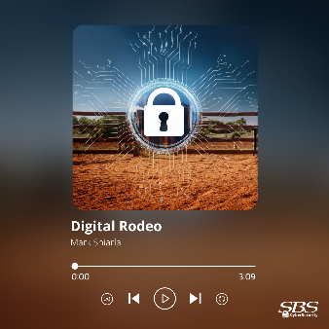
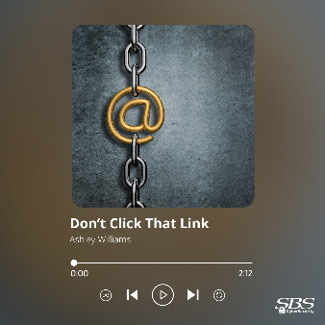

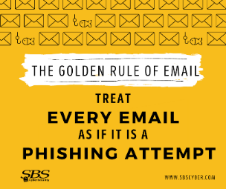
Tips
Use these tips as graphics for social media posts or use a different tip each month as the background image on your work computers. To access the complete list of cybersecurity tips and the full-size graphics, please visit sbscyber.com/education/resource-library. To download the graphics, right click on the image and choose “Save as Picture.” When applying the image to your computer background, choose “Center” in the “Choose a fit” dropdown. Add your logo to the graphic for a quick branded option.
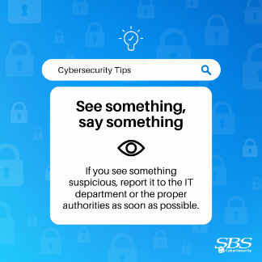
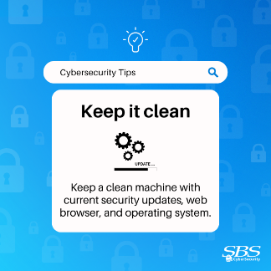
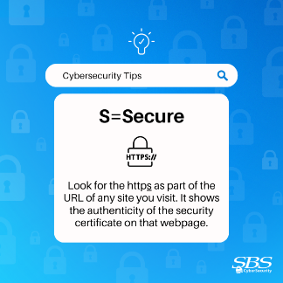
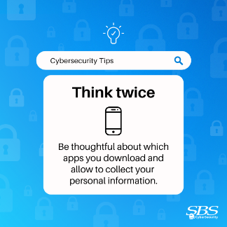
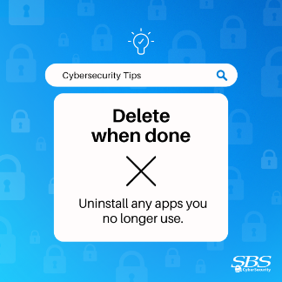
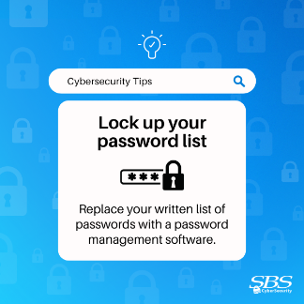
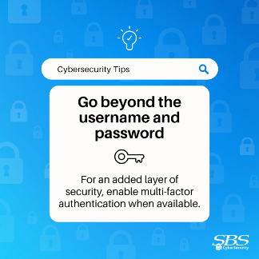
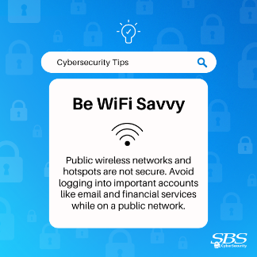
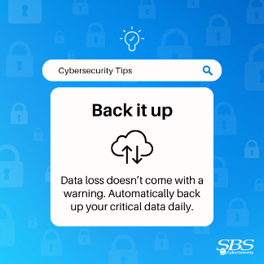
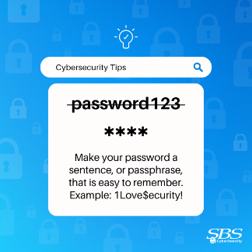
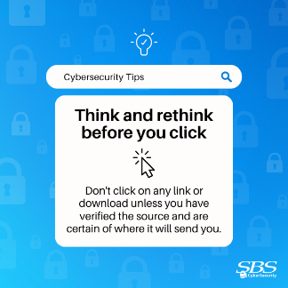
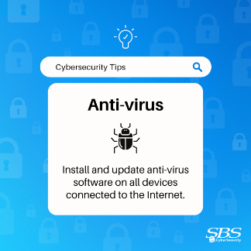
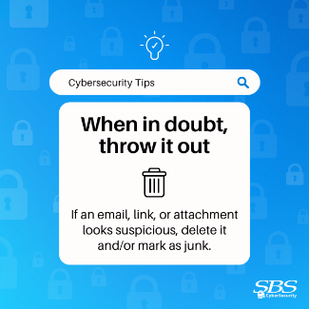
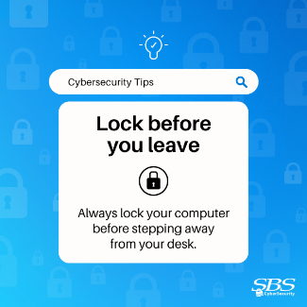
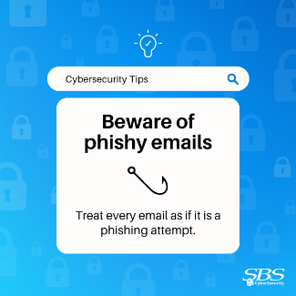


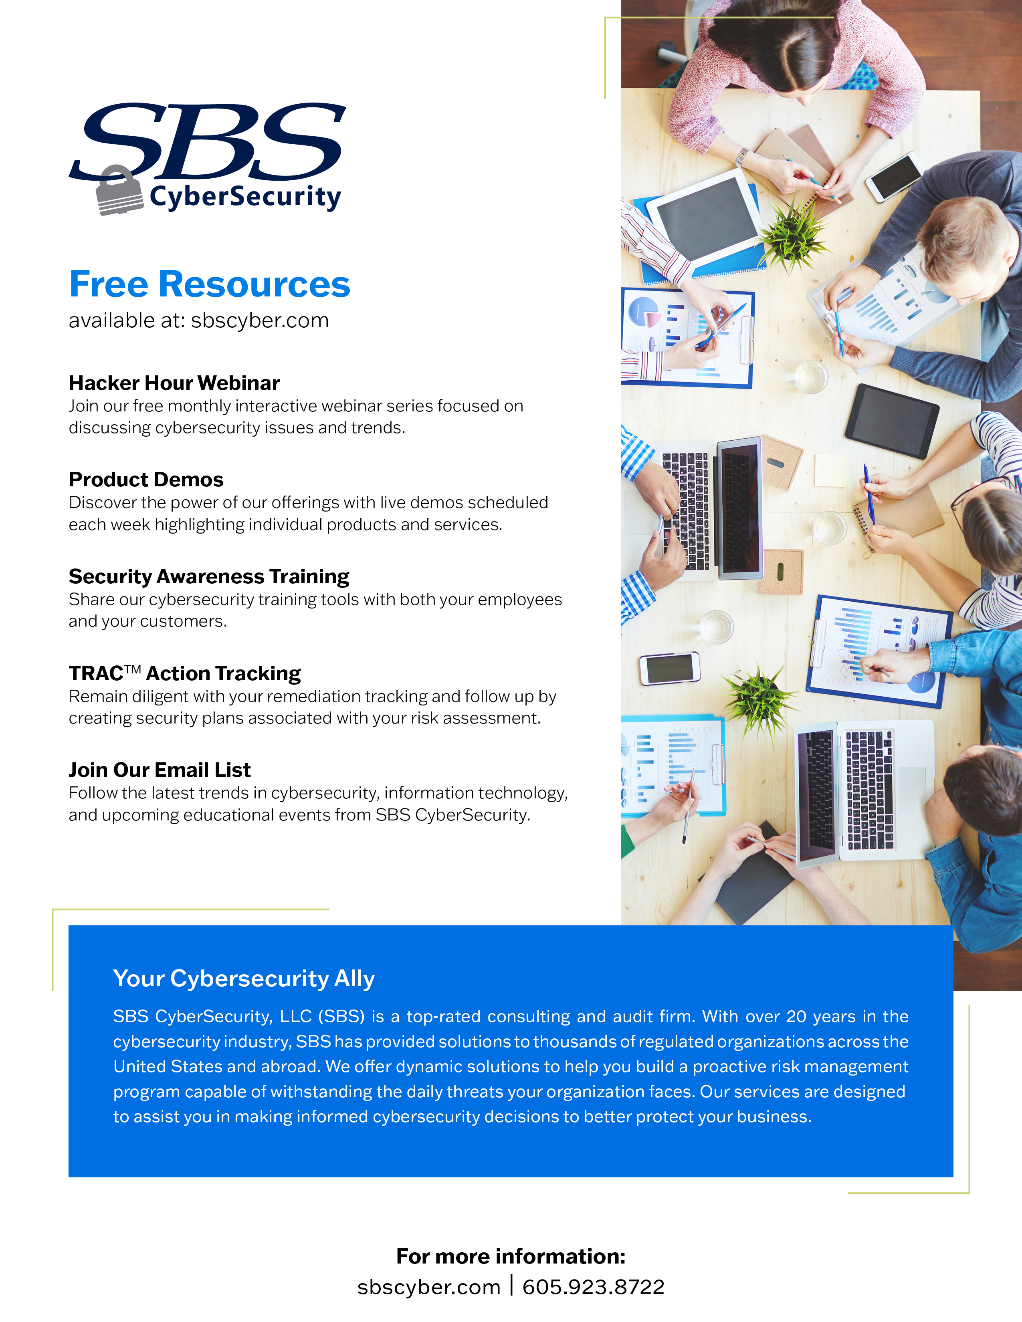
Follow SBS
For more information:
sbscyber.com | 605.923.8722

